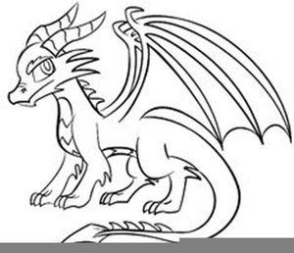

**MY PET DRAGON**

What will you name your dragon?

What will you do with it?

What will you teach it?

Will you color or decorate your dragon?